TASK 1:  
  
1. Install Monitoring Tools  
  
sudo apt update

sudo apt install htop nmon -y  
  
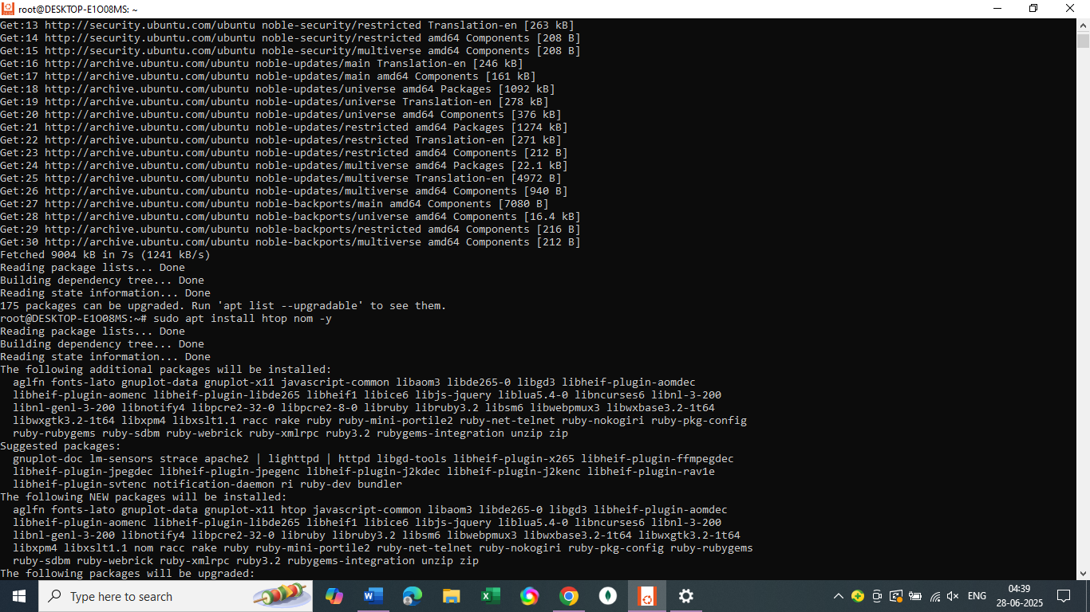

2. Run htop

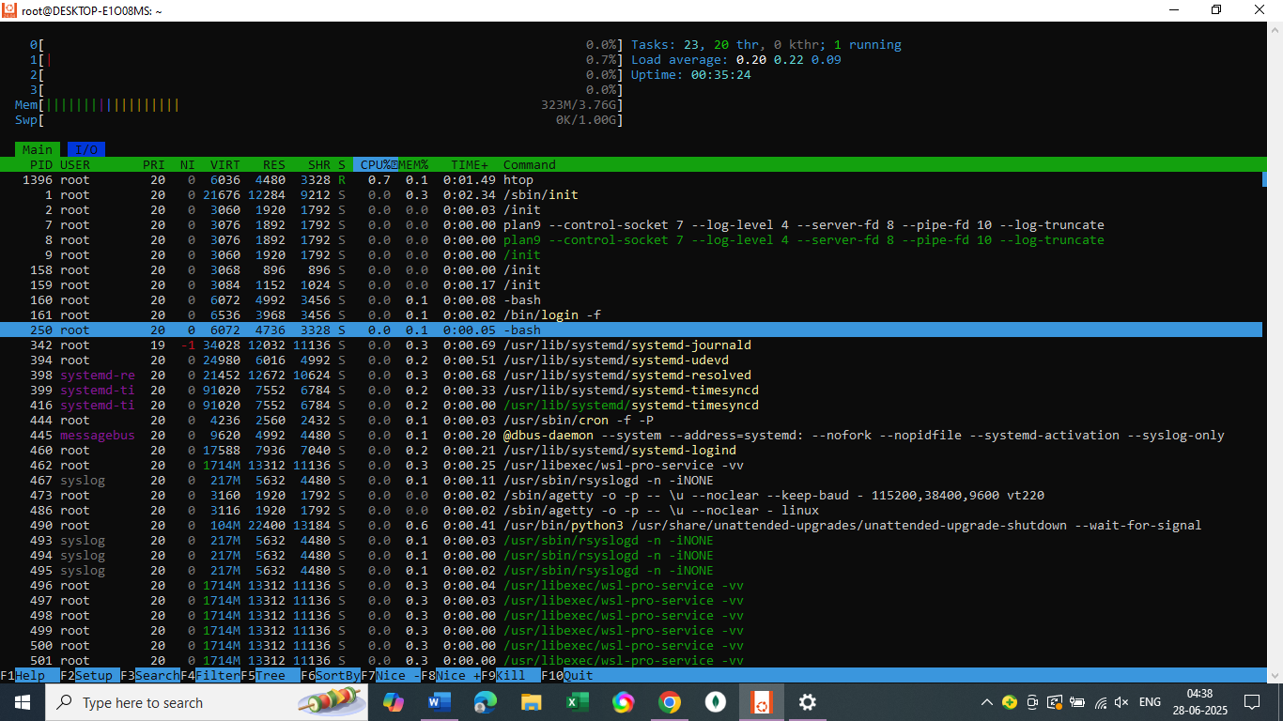

Disk usage monitoring

Nano disk_monitor.sh 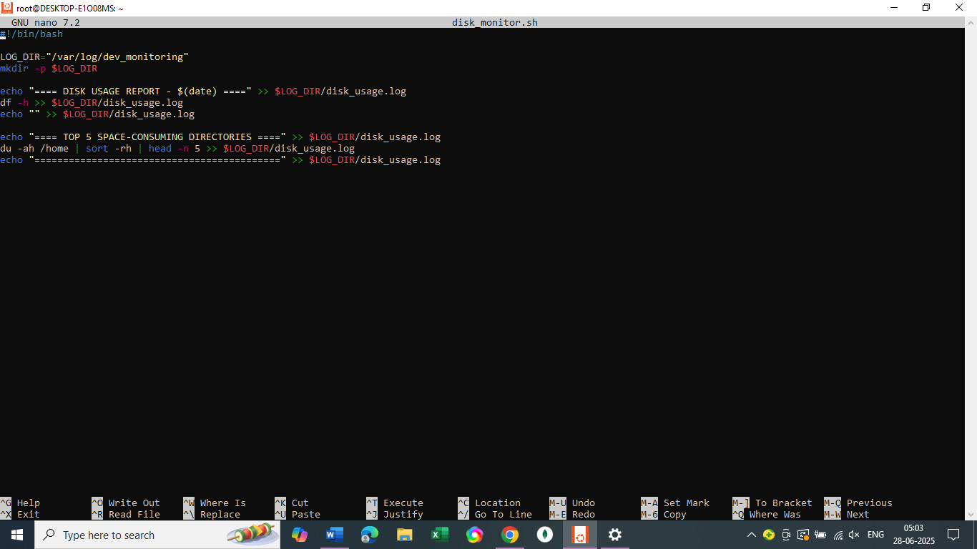

Make it as executable  
chmod +x disk_monitor.sh

**Monitoring high resource**  
  
Process_monitor.sh

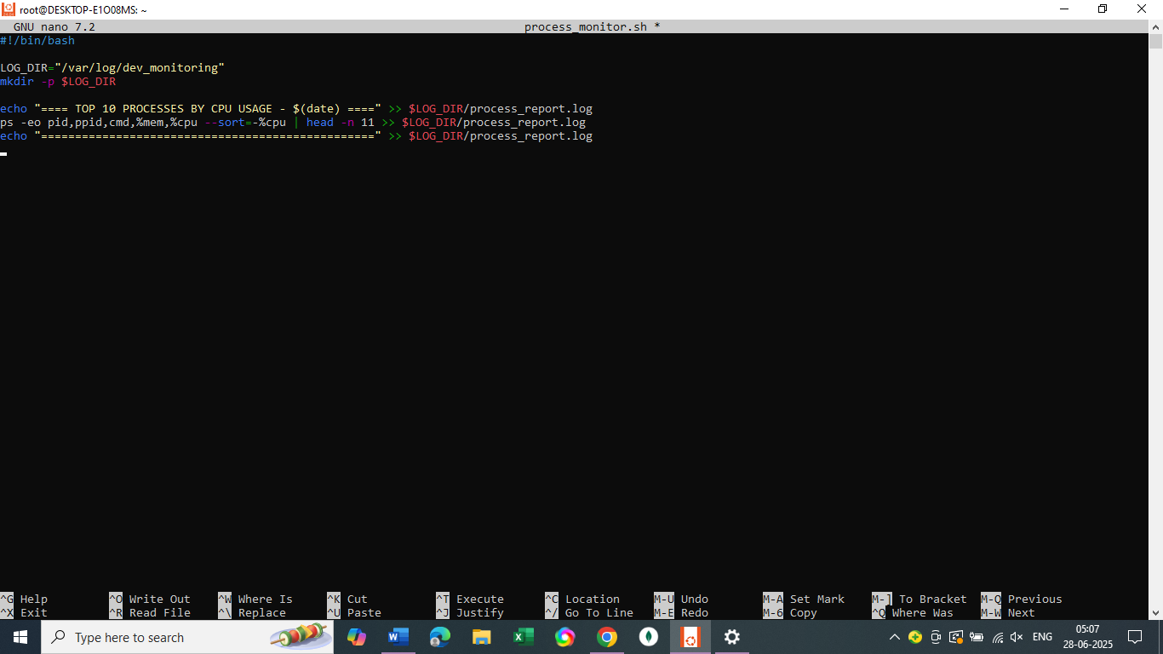

crontab -e  
  
Add  
  
*/30 * * * * /path/to/disk_monitor.sh

*/30 * * * * /path/to/process_monitor.sh

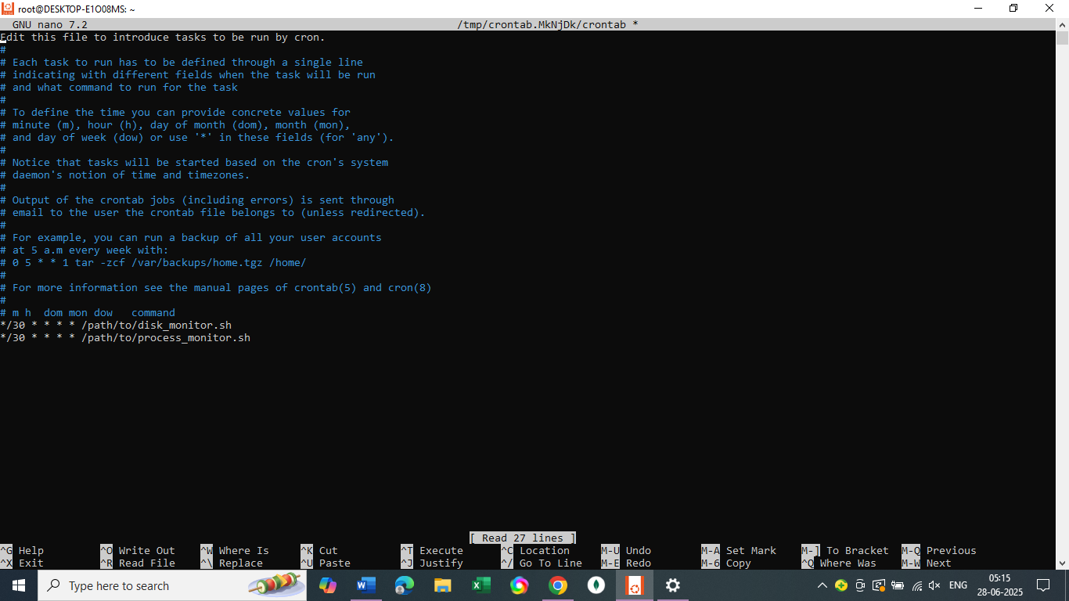

Task 2:

1. **Create User Accounts with Secure Passwords**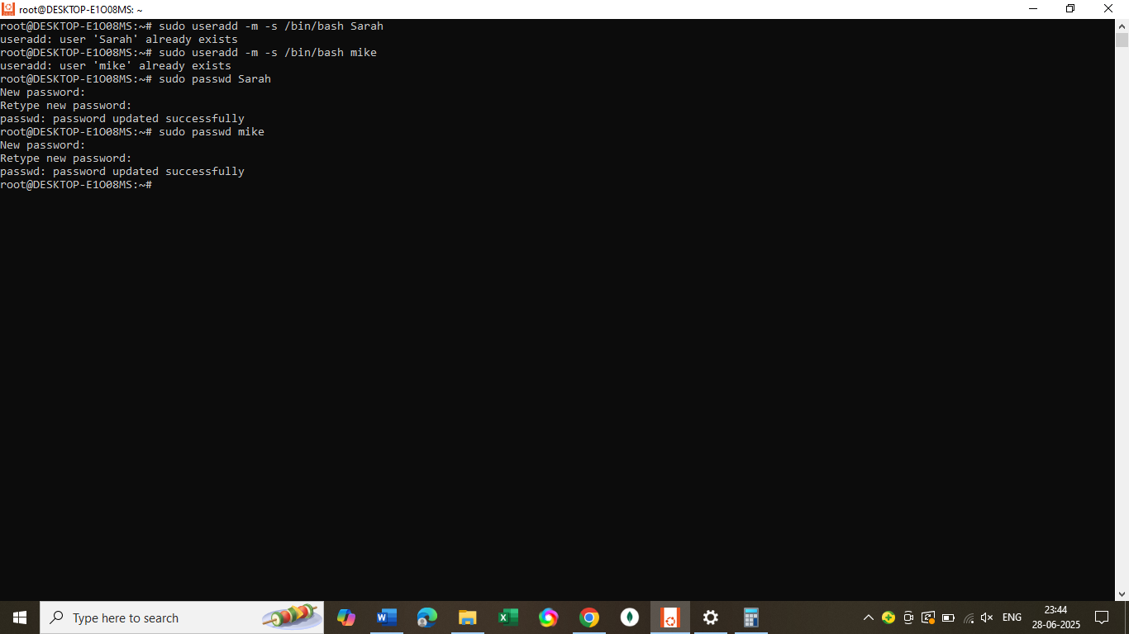
2. Create Dedicated Workspace Directories

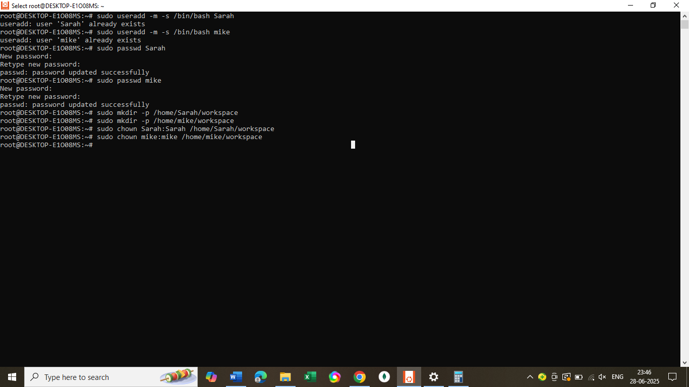

**3.Restricts Access to each directory**  
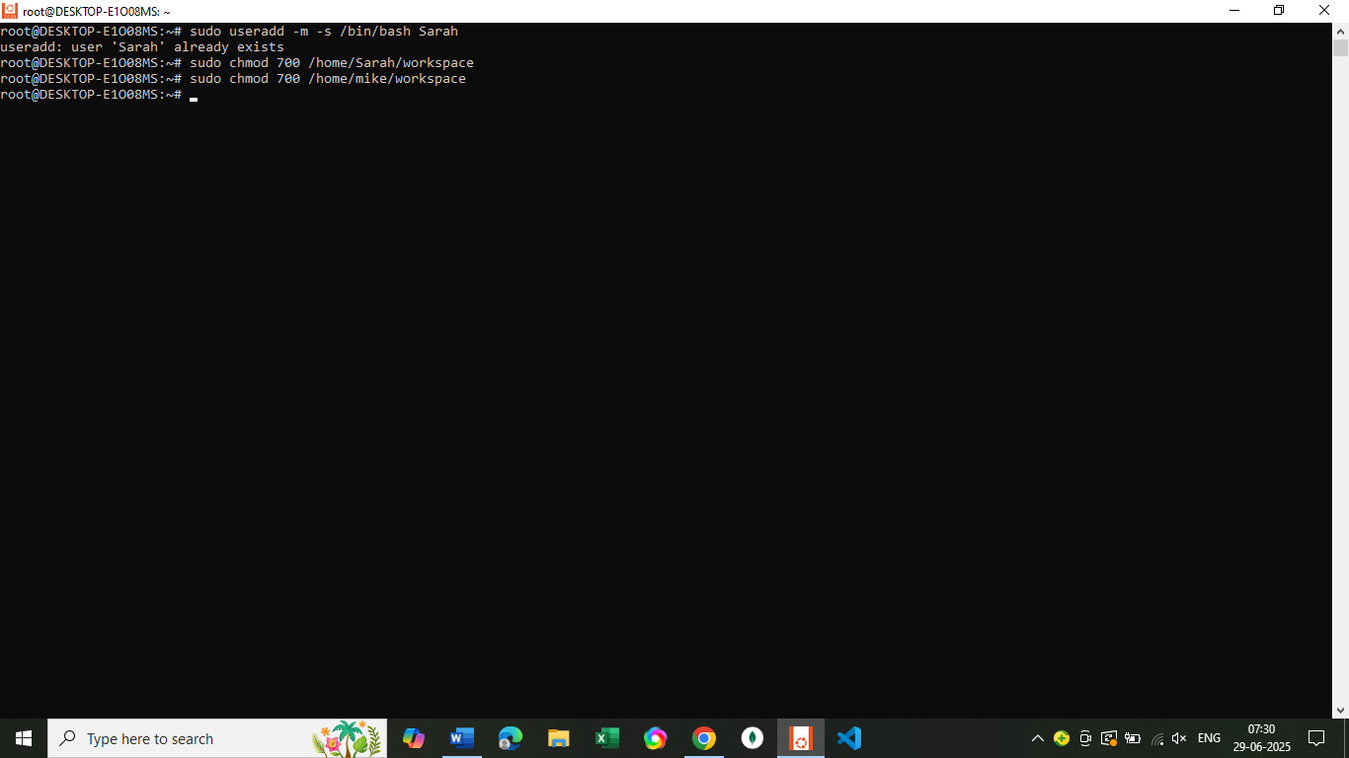  
  
# Restrict access to only the owner (700 permission)

sudo chmod 700 /home/Sarah/workspace

sudo chmod 700 /home/mike/workspace

**4.Implement Password Expiration and Complexity Policy**

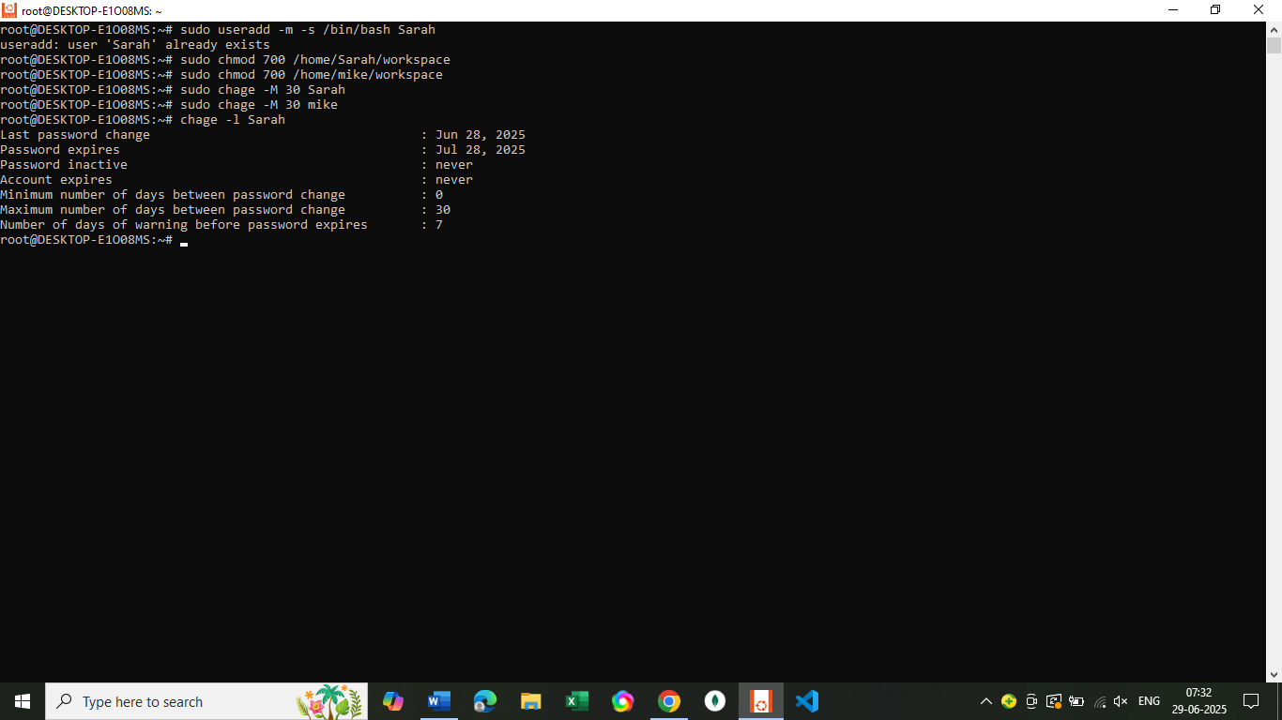

**Password Complexity**

Edit the password policy file:

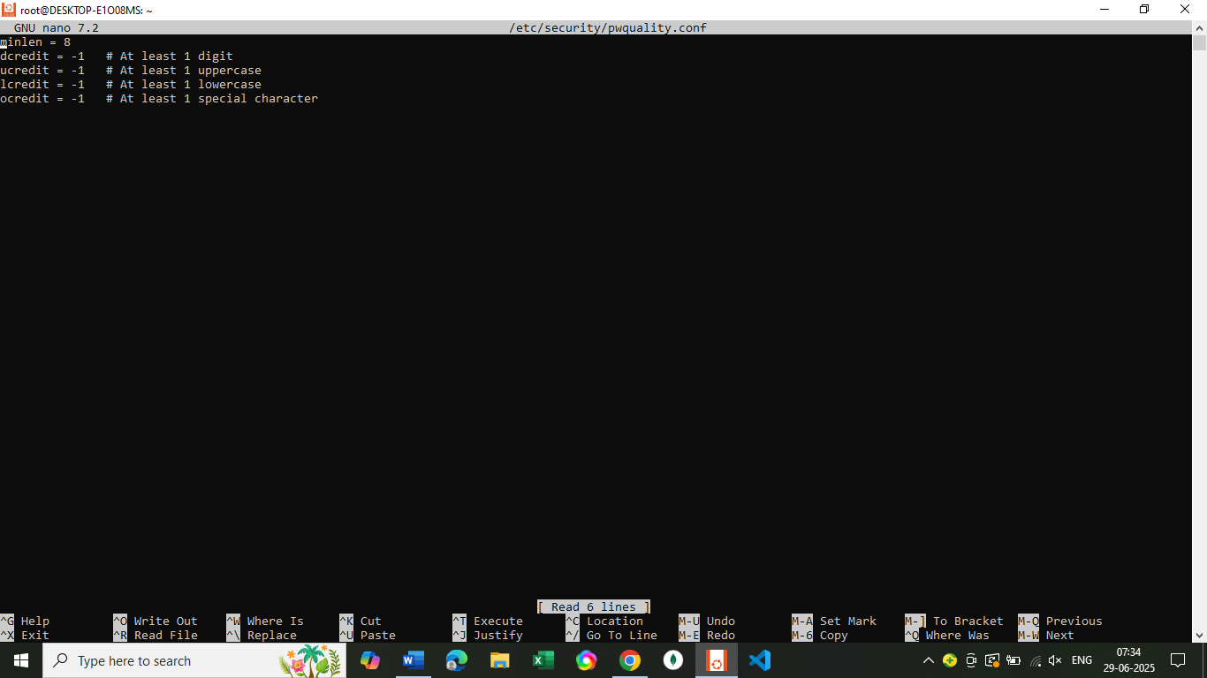

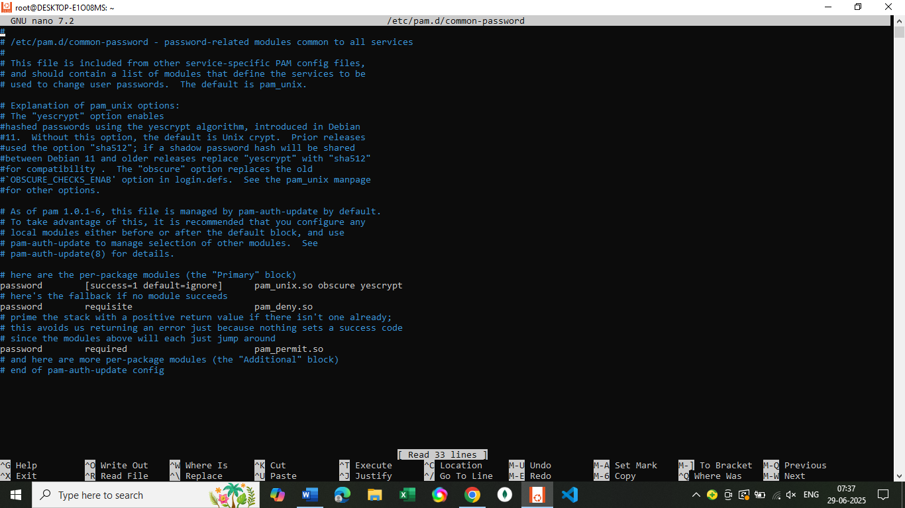

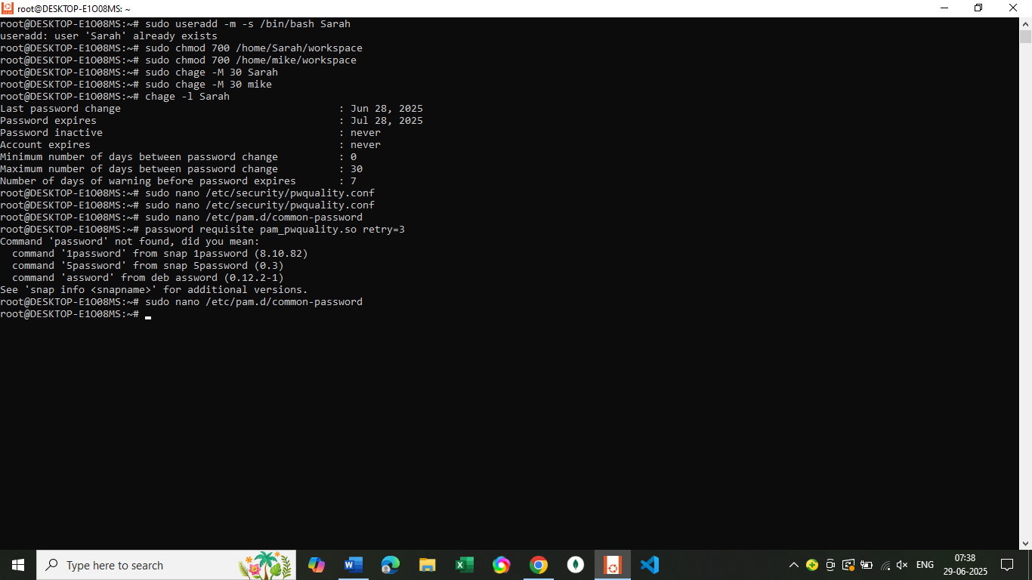

**Task 3: Troubleshooting and Backup Setup**

**1. Create Backup Directory**

**sudo mkdir -p /backups**

**sudo chmod 755 /backups**

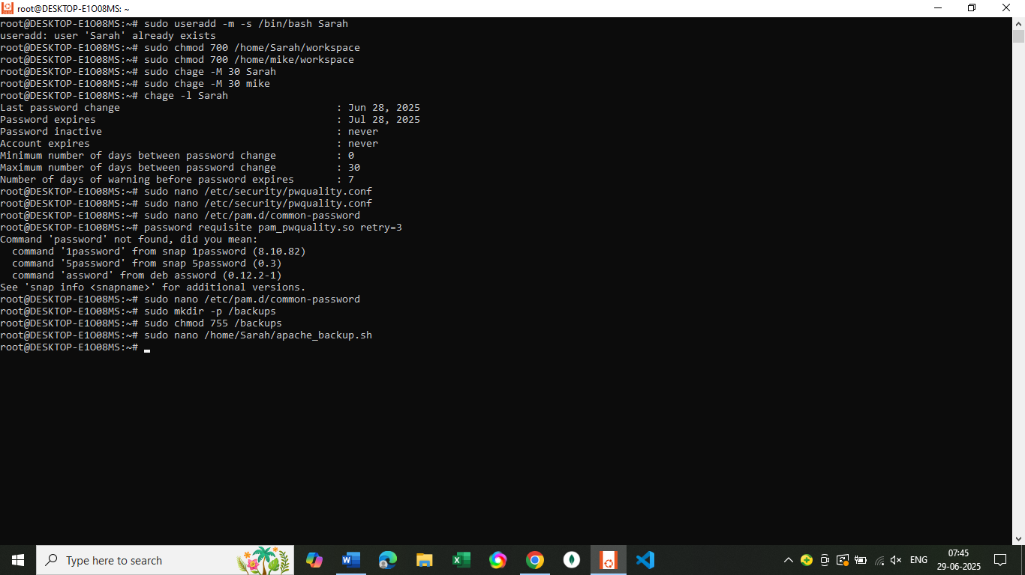

**2.Create Backup Scripts**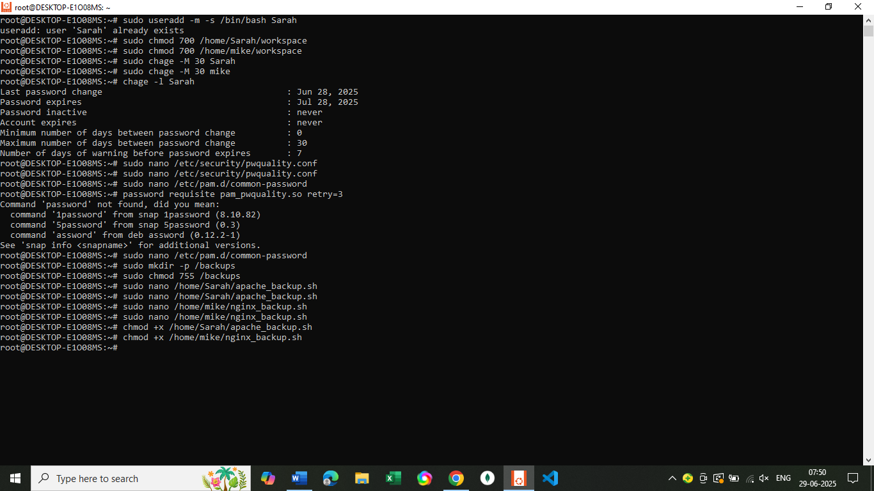

Sarah’s Apache Backup Script: /home/Sarah/apache_backup.sh  
  
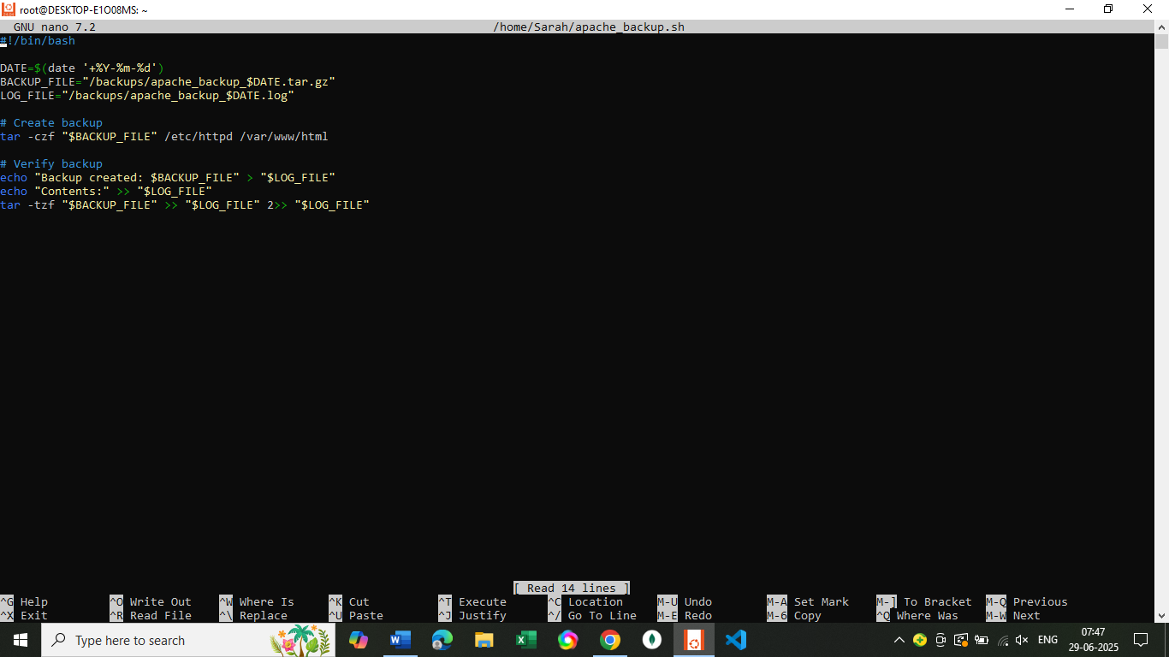

Mike’s Nginx Backup Script: /home/mike/nginx_backup.sh

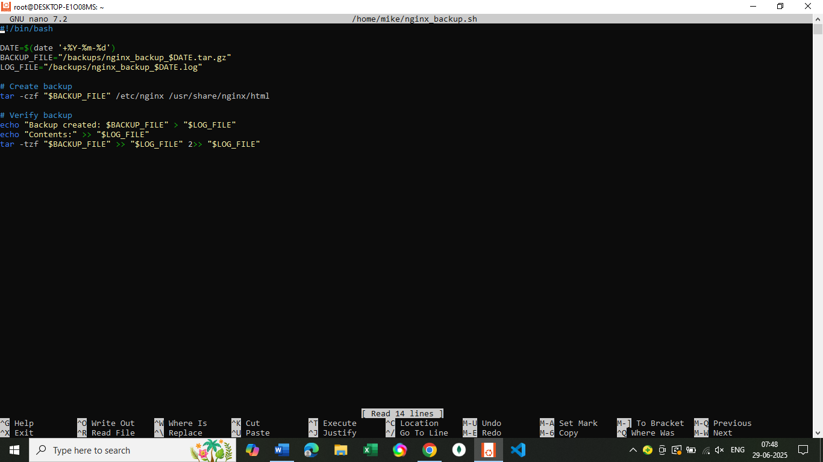

Make Both Scripts Executable  
  
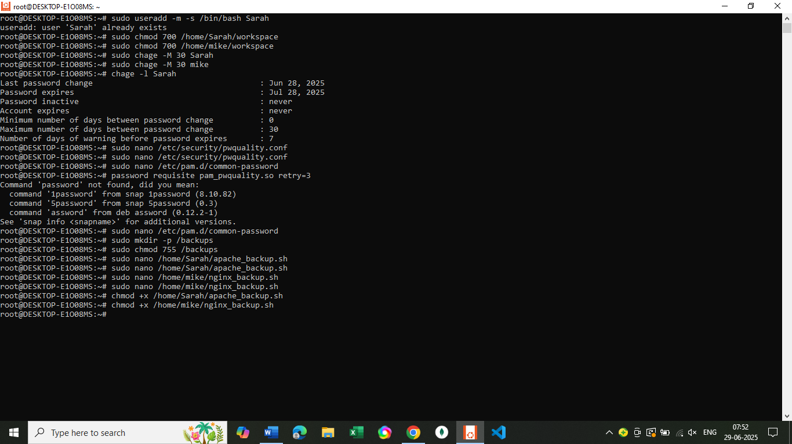

1. Set Up Cron Jobs (Scheduled Backups Every Tuesday at 12:00 AM)

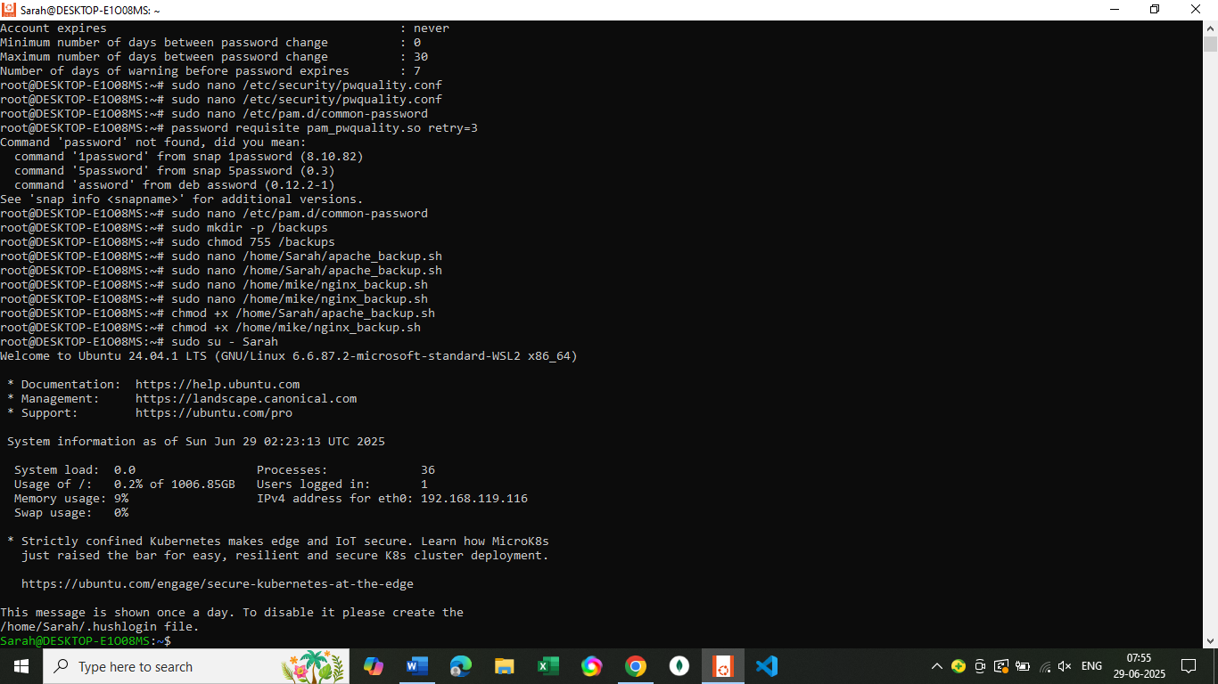

Step-by-Step Instructions to Schedule the Script

1. Switch to user Sarah  
sudo su – Sarah  
  
2. Open the crontab editor  
  
crontab -e  
  
3.Add the cron job

0 0 * * 2 /home/Sarah/apache_backup.sh

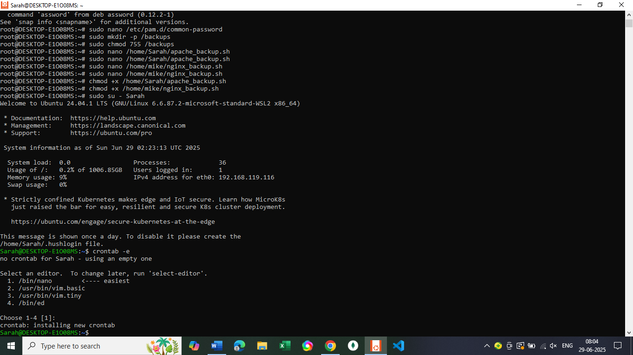

Run crontab -e **as Mike** and add:

